AttendLogServer Sample Program Usage Guide

How to run the application

Running the application from Visual Studio
Open the solution ( CsWebSDK.sln ) from Visual Studio, open the AttendLogServer project properties, and configure the debug settings as follows.
(VS2022)
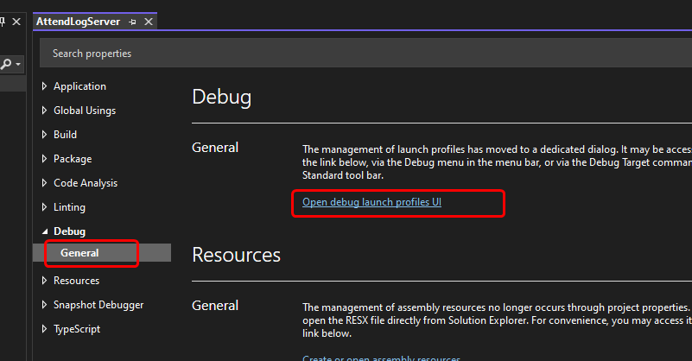
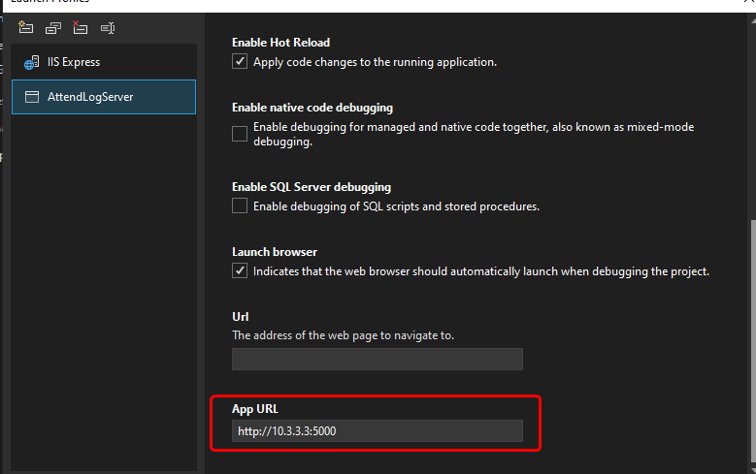

(VS2019)
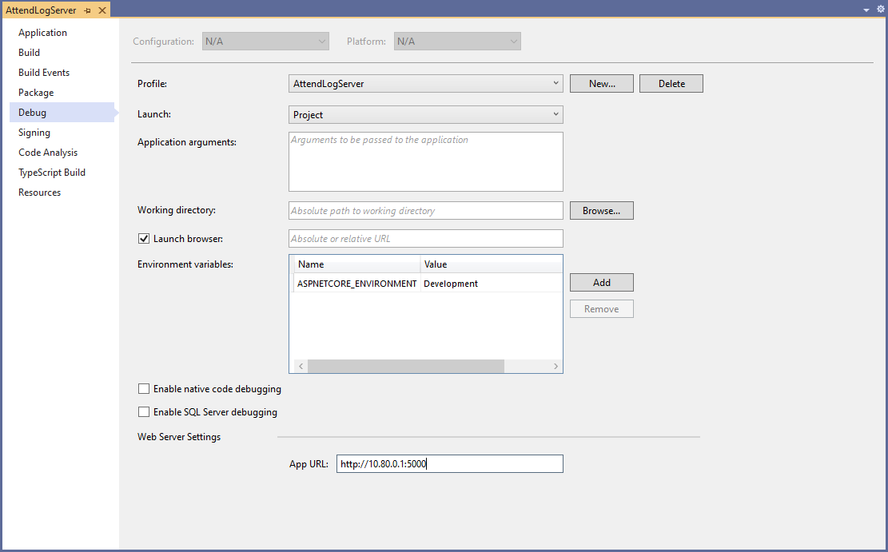
Important settings
- Launch : Select Project .
- App URL : Set it to http://computer IP address:port number
Then, run the project.

Running the Application on IIS
Please refer to https://learn.microsoft.com/en-us/aspnet/core/host-and-deploy/iis/?view=aspnetcore-9.0 .

Adding a device in the application
Open the application URL, select the Devices tab, and click the Register a Device link.
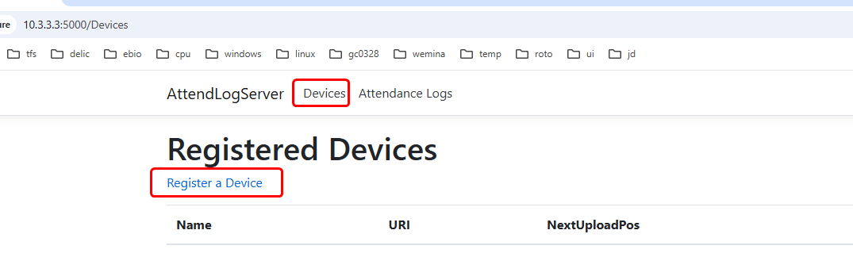
Enter a device name (used only in the app), modify the API key if needed (you can leave it at its default randomly generated value), and click the Register button.
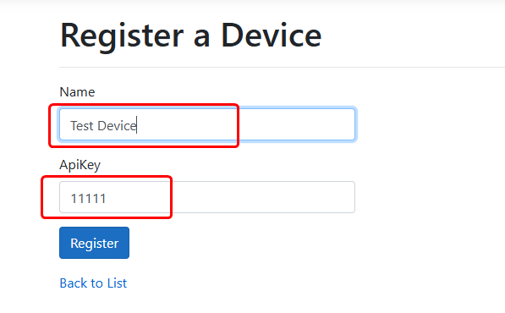

Configure the URL for uploading attendance records to the device
After registering a device, you can find its upload URL from the Devices tab.
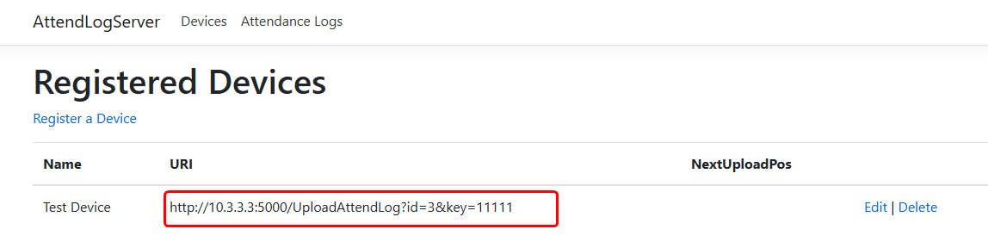
Use the SDKDemoApp application to configure the device's attendance record upload URL.
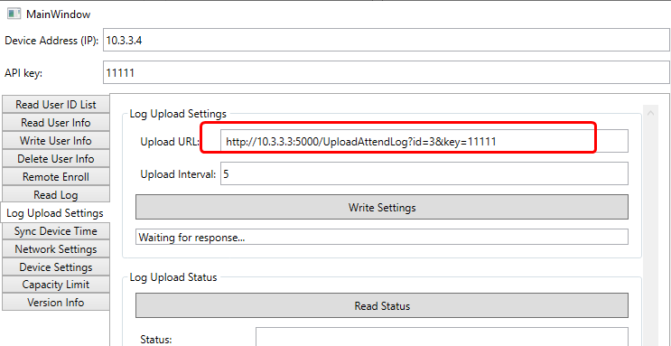

View attendance records
Open the application URL and select the Attendance Logs tab.

HTTPS Configuration
Please refer to https://learn.microsoft.com/en-us/iis/manage/configuring-security/how-to-set-up-ssl-on-iis.

